ENGLISH RANGER PASSPORt

The Great Wall Adventure

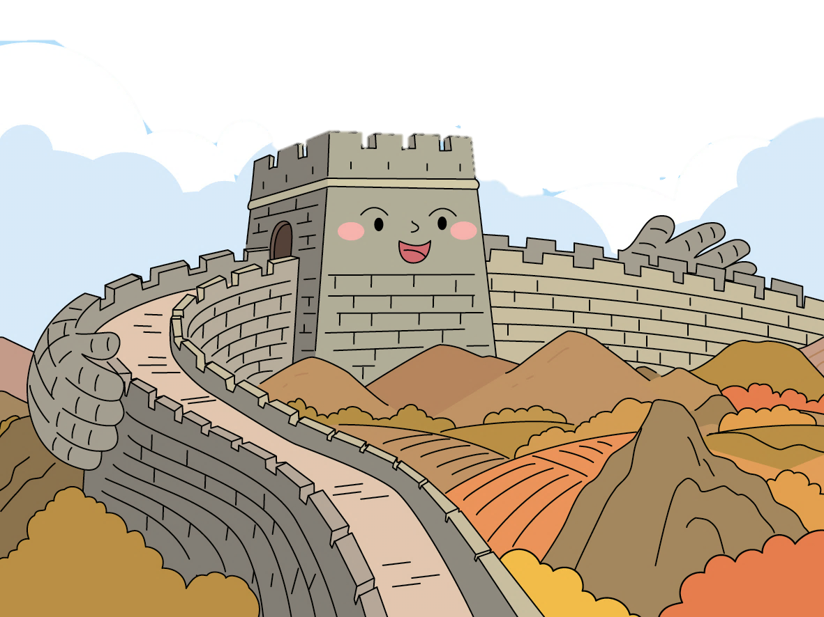
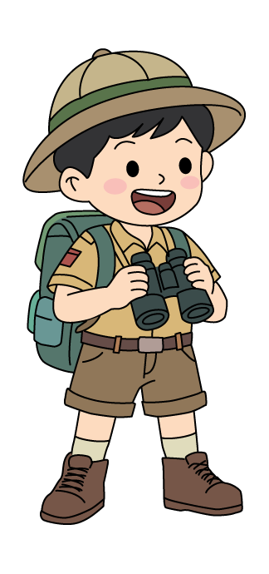
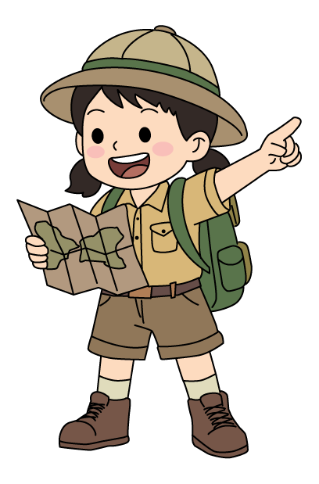
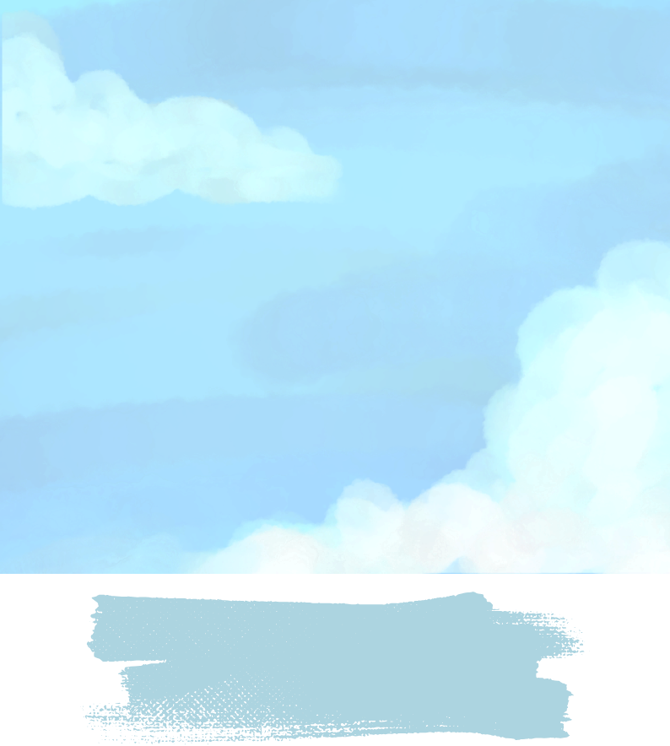
This Passport belongs to Ranger

__________________________(Name)

from Class ________________( )

English Language Education Section
Curriculum Development Institute
Education Bureau
HKSAR
© 2026
Contents
Pages

Welcome to the Great Wall Adventure, English Ranger! 1

Ranger Badge Collection 2

My Mission Goals 3

Mission 1: A Trip to the Great Wall 4

Mission 2: Steps to Discovery 5-6

Mission 3: Legacy Protectors 7-8

Mission 4: Paint with Words 9

Mission 5: Bring It to Life 10

Mission 6: Guardians of Our Home 11-12

Mission 7: Heritage in Our Hands 13-14

My Adventure Reflection 15

Welcome to the Great Wall Adventure, English Ranger!

In this adventure, you will complete seven missions. After each mission, you will earn a special ranger badge.

Here is what each ranger badge represents:
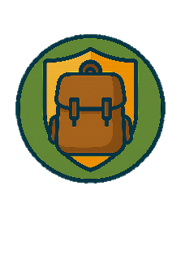

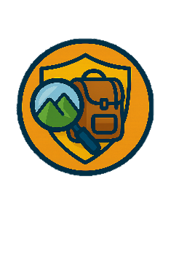
 | Explorer Badge: Observing Details
 | Wisdom Badge: Learning Diligently
 | Guardian Badge: Protecting Our Heritage and Safeguarding Our Homeland and Cultural Security
 | Language Badge: Using English Creatively

Collect all the ranger badges on the next page to show that you are a true English Ranger – curious enough to explore the history and fun facts of the Great Wall of China, brave enough to safeguard national security, and ready to share Chinese culture with people around the world, just like the guardians of the Great Wall! Colour the badges as you complete the missions!
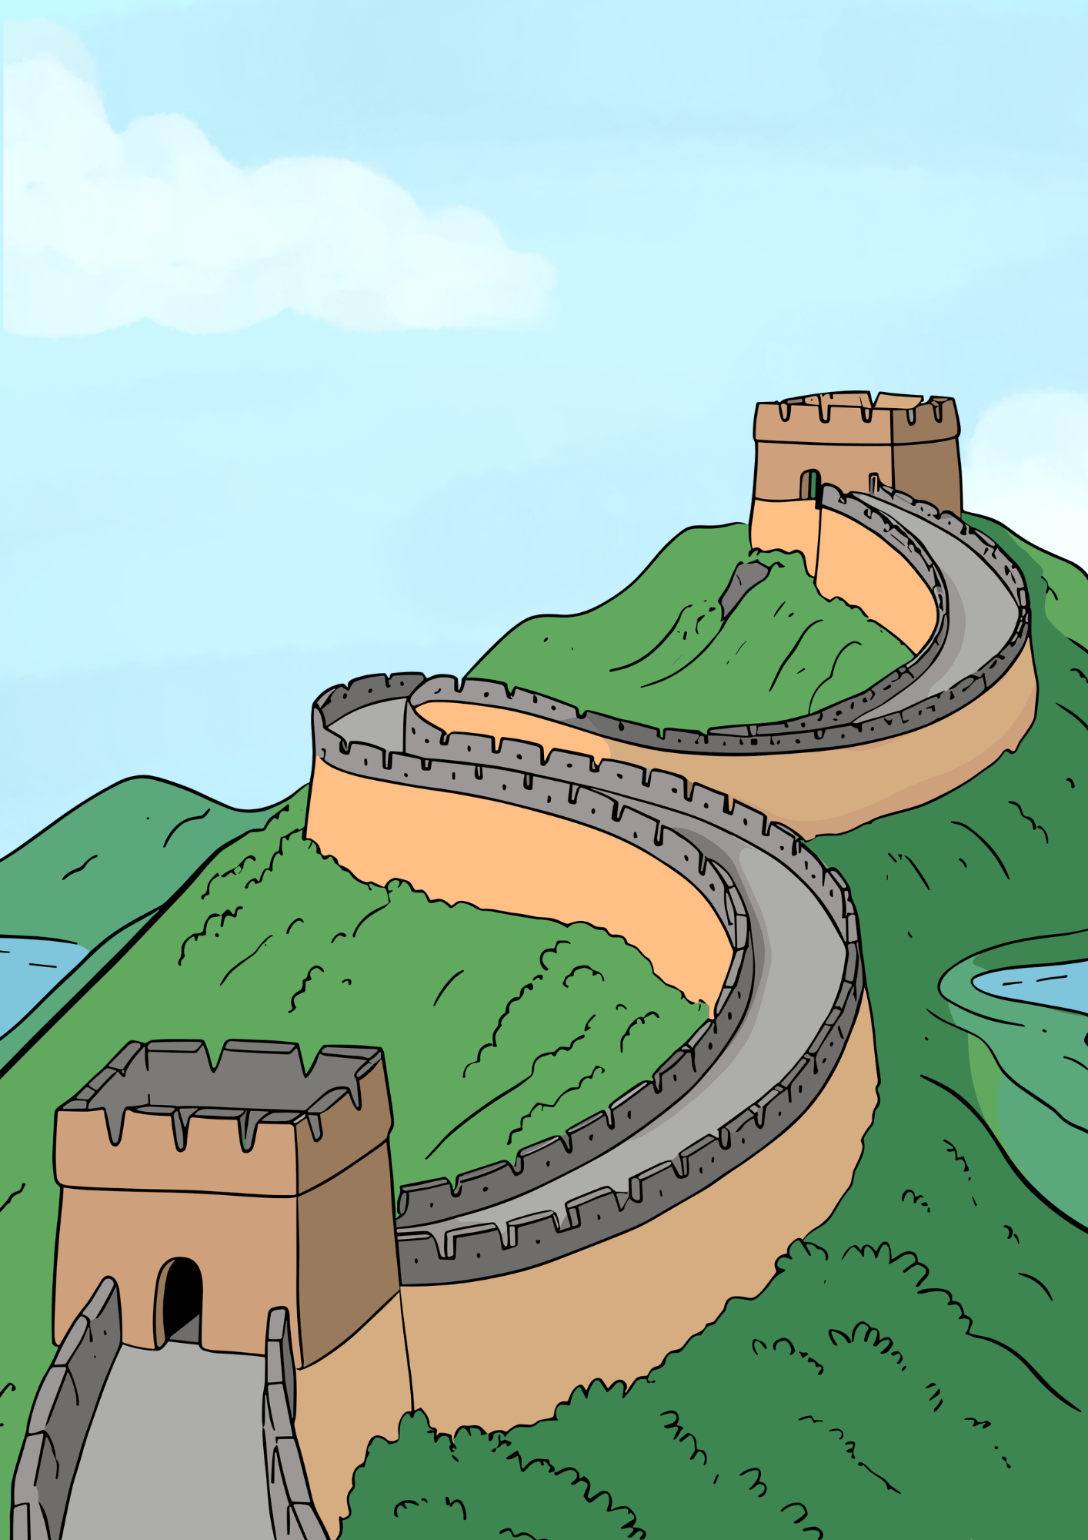
My Great Wall Adventure
Ranger Badge Collection

Mission 7

Mission 6

Mission 5

Mission 4

Mission 2
P.2
Mission 1
Mission 3
My Mission Goals

What do you want to learn through this adventure? Think carefully and tick the boxes.

I want to learn …
the history and fun facts of the Great Wall of China (e.g. How long is the Great Wall?).
ways to describe the Great Wall of China (e.g. How can I use words to bring the Great Wall to life?).
how people protect the Great Wall of China (e.g. Why has the Great Wall stood for so many years?).
why we need to protect the Great Wall of China.
what we can do to protect the Great Wall of China.
other: ____________________________________
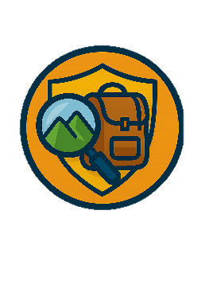
Mission 1: A Trip to the Great Wall


Have you ever been to the Great Wall of China? Take a virtual tour along the Mutianyu Great Wall. Click the link below or scan the QR code.
https://en.mutianyugreatwall.com/
(Find “Plan Your Visit” on the menu bar, then click “Virtual Tour – 2”)

Let’s Play Adjective Showdown!
Adjectives are words that describe people or things, e.g. “Mary loves to learn. She is bright and curious.” What adjectives can you use to describe the Great Wall of China?

Write as many adjectives as you can think of in the box below. Then, play Adjective Showdown with your classmates. Take turns to say one adjective each time. Do not repeat adjectives that have been used. A player who runs out of adjectives is out. The game continues until only one player remains, and he/she is the winner.
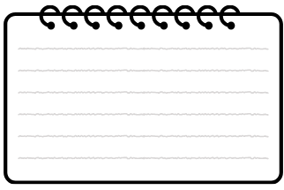
Examples:
ancient, magnificent, strong


Mission 2: Steps to Discovery

Sophie and Charlie are visiting the Great Wall of China. Listen to their conversation in the audio drama episode Guardians of the Great Wall. Then, answer Questions 1-4 by circling the best option(s) and complete the sentence in Question 5.
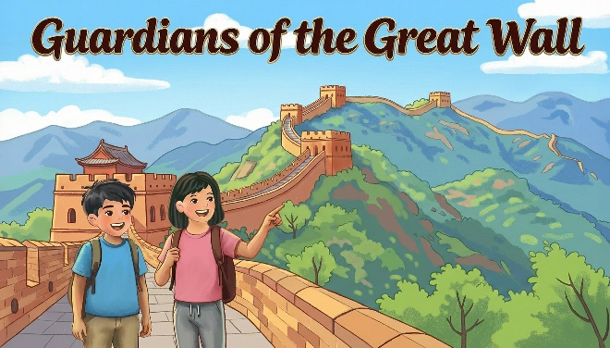


- How do Sophie and Charlie get to the top of the Badaling section of the Great Wall? (00:30-00:58)
(i) on foot (ii) by car (iii) by cable car
- (i) only
- (i) and (ii)
- (ii) and (iii)
- (i) and (iii)

- How long is the Badaling section of the Great Wall that is open to tourists? (02:00-02:17)
- 500 metres
- 2,741 metres
- 3,741 metres
- 21,196 metres
3. Why did the people in the Ming Dynasty build the Great Wall even though it took decades to finish? (02:28-03:10)
- They wanted to build the Wall for decoration.
- They wanted to carry the stones up the mountains to keep fit.
- They wanted to try building the Wall without machines.
D. They wanted to protect the land by keeping invaders away.

4. Drones act as the guardians of the Great Wall because they can _______. (You can choose more than one option.) (03:53-04:23)
- take photos to help preserve the Great Wall
- deliver stones to help decorate the Great Wall
- deliver food to people on the Great Wall
- help keep visitors to the Great Wall safe

5. Sophie says the Great Wall is a symbol of national security. What does national security mean? Listen to the episode again and fill in the blanks. (04:55-05:29)

“It means keeping China, our country, safe, strong and united - just like the Great Wall once did.”

Mission 3: Legacy Protectors

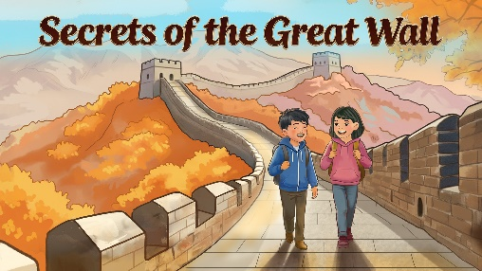
Now listen to the audio drama episode Secrets of the Great Wall. Then, answer Questions 1-4 by circling the best option(s).

- Uncle Wang is a restorer of the Great Wall. What does “restorer” mean? (01:31 – 01:48, 02:06-02:28)
- a person who repairs and preserves the Great Wall
- a person who visits the Great Wall to take photos
- a person who guarded the Great Wall in ancient times
- a machine that breaks walls and builds new ones

- Which of the following sentences is NOT true?
(02:27-03:54)
- Some parts of the Great Wall have disappeared completely.
- People repair all damaged bricks on the Great Wall with modern ones.
- People make bricks with traditional methods to replace missing bricks on the Great Wall.
- Archaeologists, scientists and restorers work together to preserve the Great Wall.

- Why do restorers use the original materials to repair the Great Wall? (You can choose more than one option.)
(02:47-03:54)
- to save time
- to save money
- to keep its historical and cultural values
- to match the appearance of the Wall

- How can the four-legged robot help protect the Great Wall? (04:09-04:44)
- It can take photos of damaged parts with its cameras.
- It can detect cracks or missing bricks with its sensors.
- It can send real-time data to restorers.
- All of the above.


Think and Share (Accept any reasonable answers.)

1. What can you do to help protect the Great Wall of China?
Tick the boxes.
⬜ Do not litter and keep the Great Wall clean.
⬜ Visit the Great Wall and learn more about its history.
⬜ Take photos and share the beauty of the Great Wall with others.
⬜ Other: _________________________________________
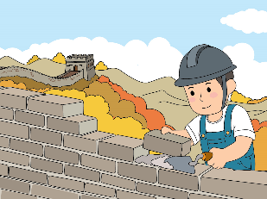

2. The restorers have worked hard to keep the Great Wall safe and strong. What part of the restorers’ job impresses you the most?
________________________________________________________________________________
- Mission 4: Paint with Words

The Great Wall of China is world-famous. Millions of tourists visit it every year to appreciate its beauty.



(a) Listen to the audio drama episode Guardians of the Great Wall again. How does the narrator describe the beauty of the Great Wall? Fill in the blank. (01:21-01:29)
“The Great Wall stretches across the mountain ridges like a majestic dragon, guarding the land for centuries.”
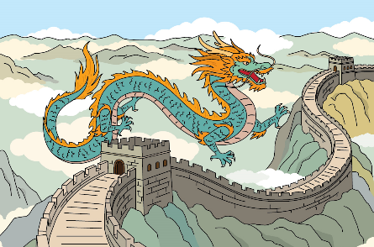


(b) A simile compares two things using the words “like” or “as”. Read the similes and fill in each blank with the best word.
jelly giant hummingbird

- These steps are steep … My legs feel like jelly!
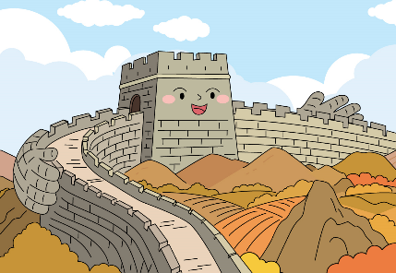
- A sharp buzzing sound zips through the sky, darting like a hummingbird.
- The Great Wall is like a proud giant stretching its arms wide to shield the land.

(c) Write one simile to describe the Great Wall of China.
(Accept any reasonable answers.)
The Great Wall ____________________________
________________________________________
________________________________________

Mission 5: Bring It to Life

Personification is a writing technique in which animals, plants, or objects are described as if they were people. It makes descriptions more vivid and easier to imagine.

The opening of the audio drama episode Secrets of the Great Wall uses personification to describe the setting. Listen to the opening again (00:10-00:30). Draw pictures and colour them to complete the scene in the photo. Then circle the best answer to complete the caption.

“The crisp air tickles their cheeks. Golden leaves cover the mountains like a glowing blanket. The sunlight dances on the ancient stones.”

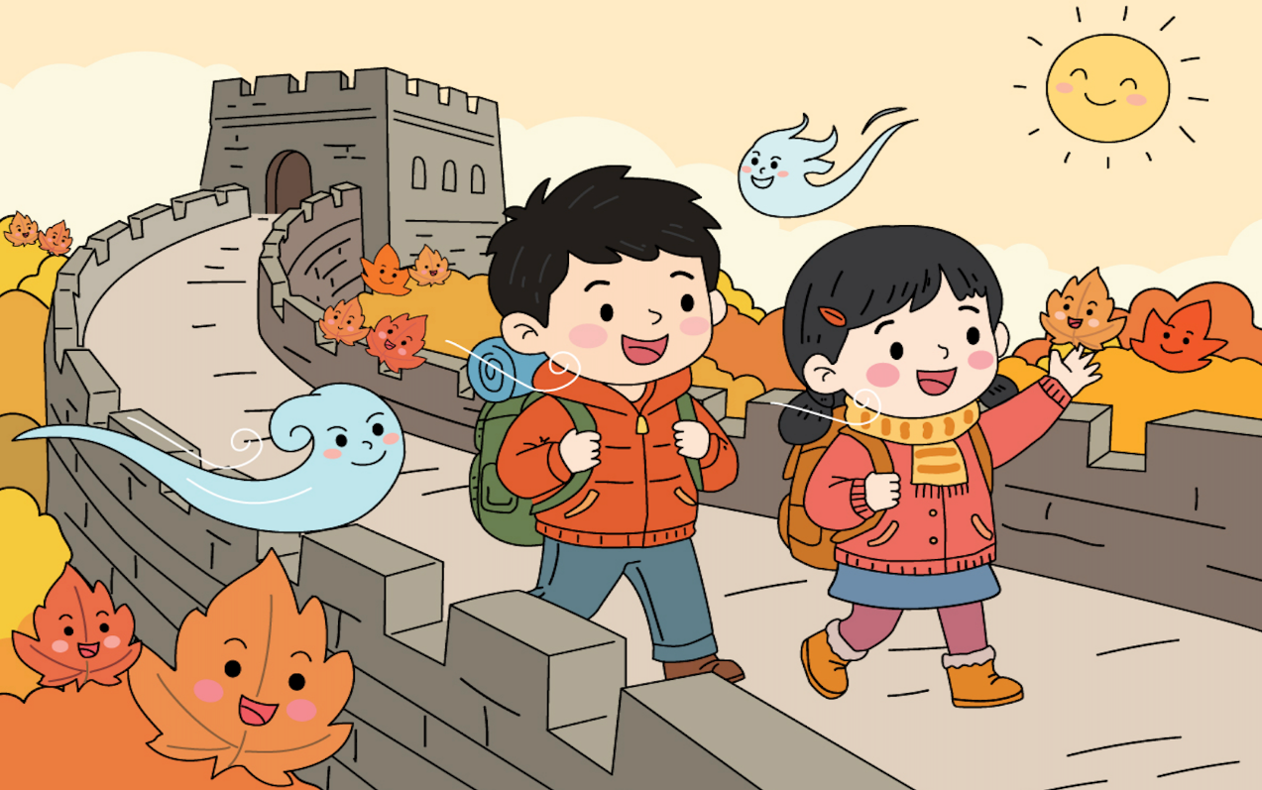

Sophie and Charlie are hiking on the Great Wall of China. The scene feels (magical / scary / noisy / gloomy).
Mission 6: Guardians of Our Home

Sophie and Charlie want to tell their friends about the Great Wall of China. Help them complete their notes.

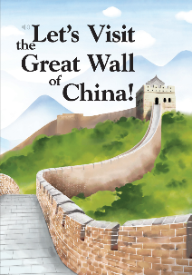
(a) Read the reader Let’s Visit the Great Wall of China! (Sections 2-3) to learn about the history and the structure of the Great Wall. Then, fill in the blanks.
Qin Shihaung ordered his workers to build the Great Wall of China to protect his people and the land. The Great Wall was mainly made of soil, wood, stone and brick. Soldiers at the watchtowers sent smoke signals to alert others to incoming invaders.
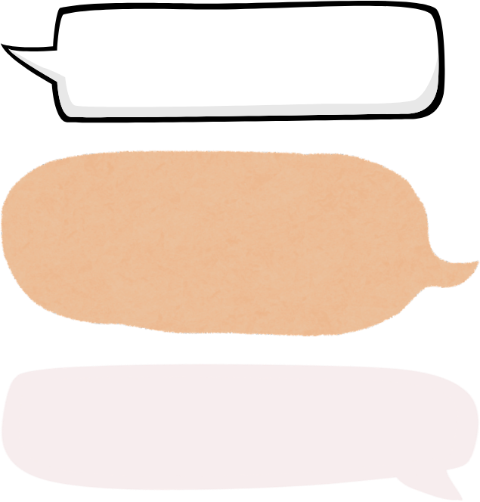
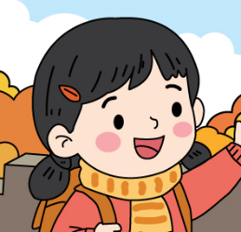
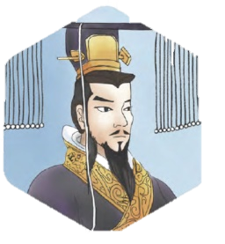

(b) Read Section 6 of the reader to learn about how people nowadays preserve the Great Wall. Then, fill in the blanks.
Today, scientists in our country use modern technology such as drones to collect images of damage to the Great Wall. They repair damaged sections to keep the Wall strong, so that everyone can enjoy the beauty of this historic attraction.
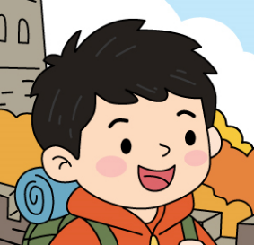
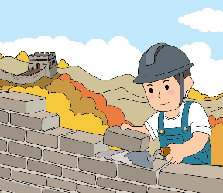

(c) Protecting our country is as important as protecting our home. Look at the pictures below. What would you do to protect your home? Write your ideas on the lines.
(Accept any reasonable answers.)

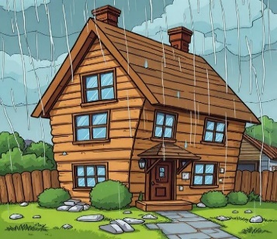
Situation 1: A typhoon is coming.
__________________________________________________________________________________________________________________


Hints:
- What can we do to the windows and doors?
- Where do we move the flower pots?
- Should we stay near the windows?

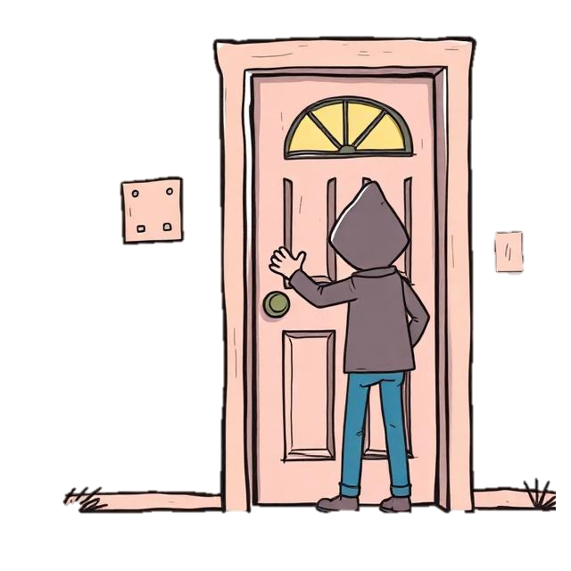
Situation 2: A stranger knocks on your door.
__________________________________________________________________________________________________________________


Hints:
- Should we open the door?
- What questions can we ask?
- Who should we ask for help?

Think and Share
Why is it important to protect our home? How do you feel when your home is not safe? Share your ideas with your teachers and classmates.
________________________________________________________________________________________________
Mission 7: Heritage in Our Hands

The Great Wall of China is a national treasure and a source of pride for Chinese people. What cultural values does it have? Read the hints and fill in the blanks. Then find the words in the word search. The first one has been done as an example.
Hints:
- In the past, the Great Wall was built for protection. Today, it is an important part of our c .
- Chinese people built the Great Wall without modern machines. This shows their p .
- The Great Wall is a symbol of u and national security.
- Many people visit the Great Wall to appreciate its b and learn about its h .

Words are hidden horizontally, vertically and diagonally.



Time to “Speak Your Mind”

Create a 3-minute short video to encourage others to help preserve the Great Wall of China, our national treasure. You may include these messages:
Key Messages | Your Notes
History and fun facts:  - When was the Great Wall of China built?  - What was it made of?  - Where is it? How long is it? | (Accept any reasonable answers.)
Problems:
- What natural and human challenges does the Great Wall of China face?
Saving our heritage:
- What have restorers and scientists done to preserve the Great Wall of China?
Why it matters:
- Why should we protect the Great Wall of China?
What we can do:
- What can we do to help protect the Great Wall of China for our future generations?



Submit your work to the Student Showcase Pilot Scheme “Speak Your Mind!”. Visit this webpage for details: https://www.edb.gov.hk/SpeakYourMind.
My Adventure Reflection

Have you finished your missions? What have you learnt? Tick the boxes.

I have learnt …
the history and fun facts of the Great Wall of China (e.g. the length of the Great Wall, why people built it).
ways to describe the Great Wall of China (e.g. using adjectives, similes and personification to bring my words to life).
how people protect the Great Wall of China (e.g. using technology).
why we need to protect the Great Wall of China (e.g. understanding that it is important to protect our national heritage and safeguard our homeland and cultural security).
what we can do to protect the Great Wall of China (e.g. keeping it clean, learning about its history, sharing its beauty with others).
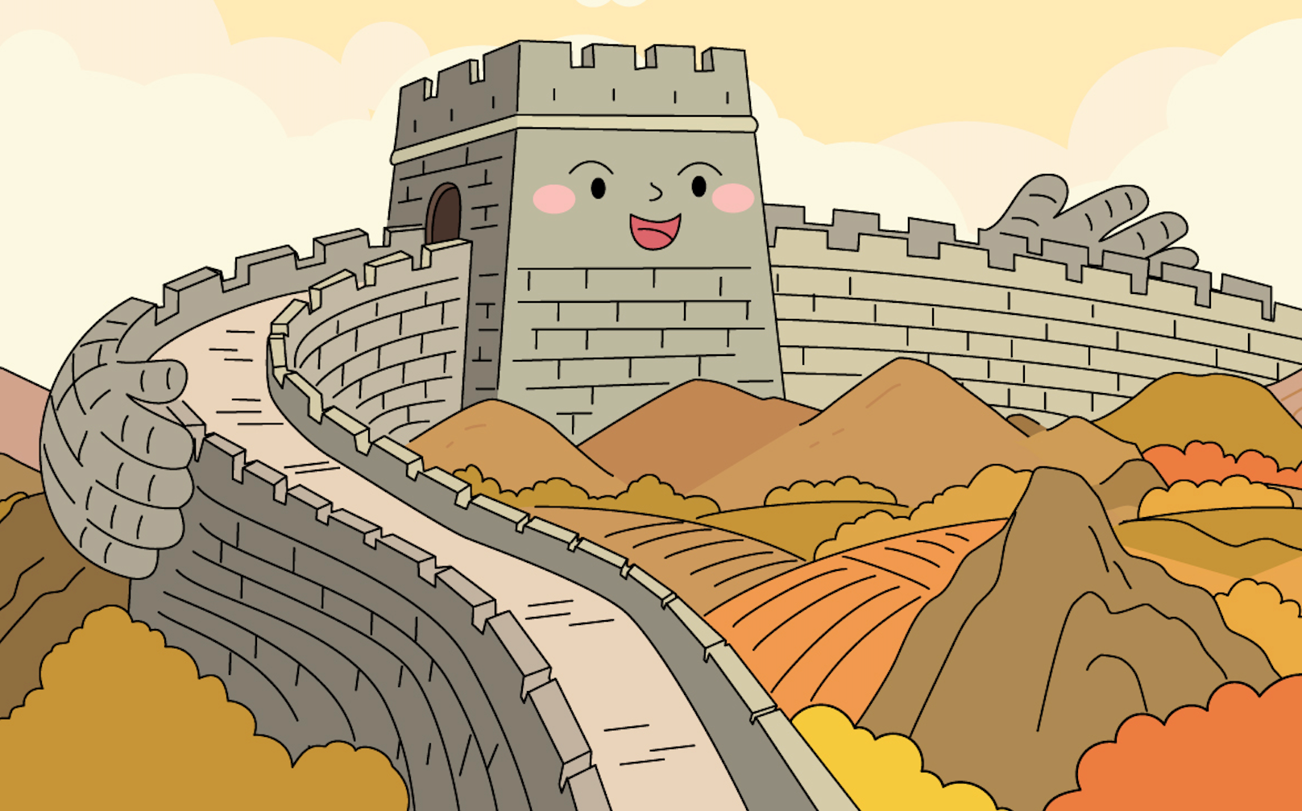
other: __________________________

P.15
Protect the Past, Guard the Future!

